CI CD LAB EXPERIMENT -10

(BY: AMAN TYAGI)

Aim: Integrate Nexus with Jenkins

1. Start Jenkins
2. Go to Manage Jenkins and download the plugin for Nexus
3. Create a new item , In the config settings add the github repo url

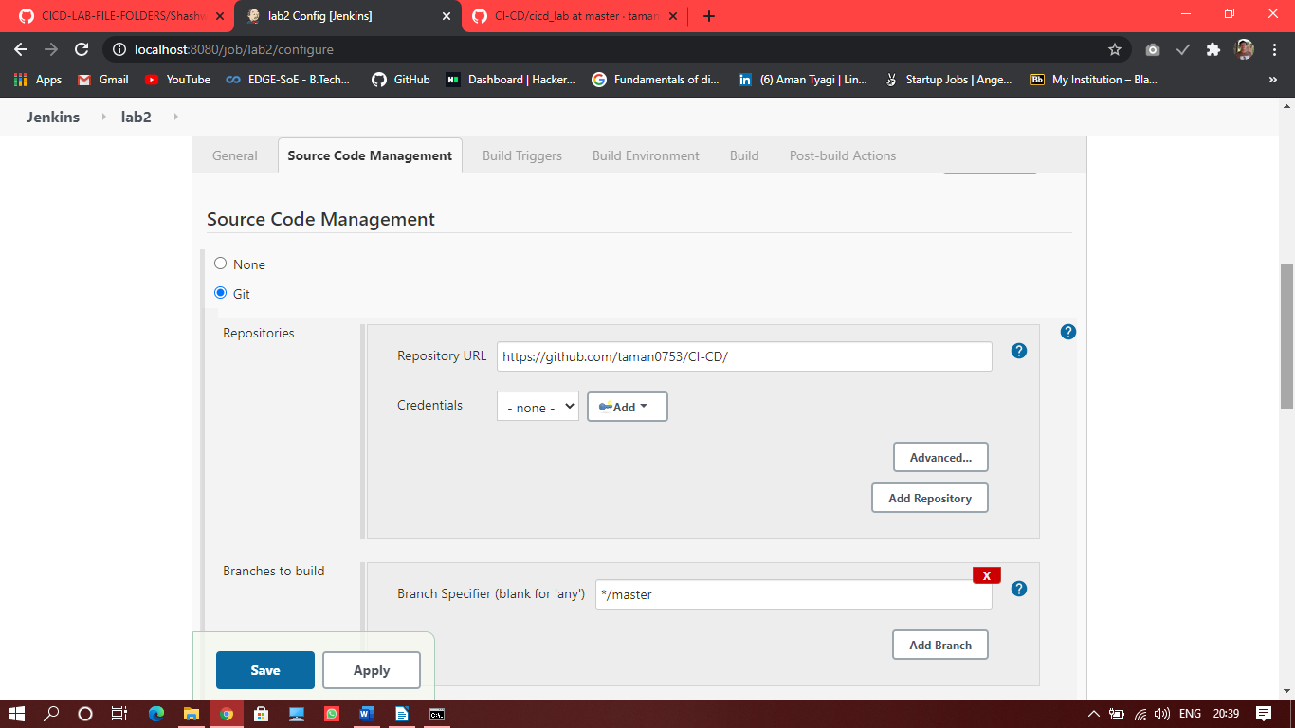

1. Select “Build” tab and add location of the pom.xml file in your github repository and the goal you want to run ,here “deploy”
2. Now go to “Configure Systems” option in Manage Jenkins and search for the tab “Sonatype Nexus”. Enter the details for the same and run the “test connection” option to check whether connection is connected or not

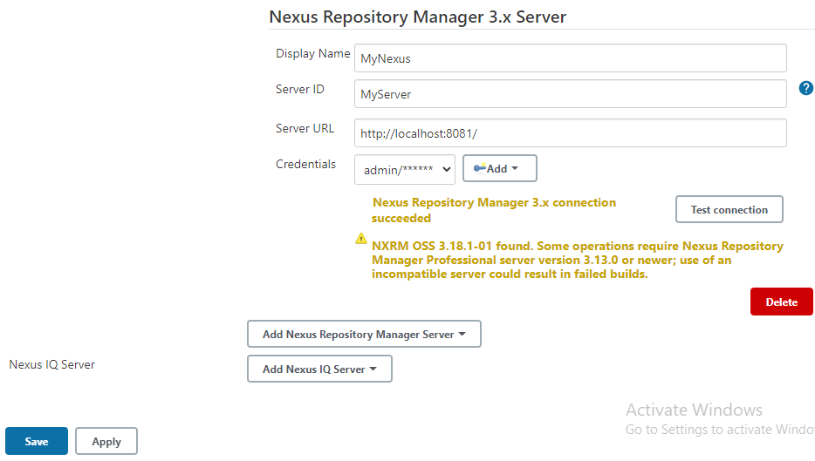

1. Select option build now and go to console output option to check the output

